Final Project Design Phase
Computer Science - Week 11
Oct 3, 2026 - Version 0.0.4

For complete instructions and project ideas, refer to the assignment in Canvas. Specifically, review the final project requirements before you continue below. If you have not reviewed the project requirements in Canvas (you might have to go to the modules view and check the current or past week's content), you will not be able to properly complete the parts below. In addition, it may be helpful to review the information on this Drafter documentation page.

0) Project Planning and Preparation
Successful programmers spend time planning before they begin coding. After reviewing the project requirements, answer the following questions to help guide your design and development process.
- What concepts from class or previous assignments might help you complete this project? Which programming concepts (loops, conditionals, lists, classes, etc.) do you expect to use? What programming skills do you want to improve while completing this project?
The drafter work and while loops are some concepts from class that will be helpful for coding. Some programming concepts that I expect to use are lists, conditionals, and potentially dataclasses. I want to improve drafter while doing this project because I haven’t done as much drafter as other concepts.

- Which parts of the project do you expect to be the easiest for you? The hardest? Why?
The hardest will be the drafter and state parts, because I am not as well-versed in that area and have less experience. The easiest should be the bodies for code and making it so the information is taken by the program and then a message is returned.

- Even though you have not yet designed the final project, estimate which tasks will likely require the most time and effort? Which features or components should be implemented first?
The most time and effort-consuming part will be the troubleshooting, becuase with large codes many issues will come up so fixing them will be a challenge and take some time. The features that should be implemented first will be the simpler parts of the code, like taking in a fish and storing the data from that one, and maybe also finding some of the stats related to that.

- What distractions might interfere with your work and how will you minimize them? What resources will you need available while working? What questions, if any, do you still have about the assignment requirements?
The only distractions might be other classes and work for those; I will minimize those by taking the correct time to complete the Comp Sci work before it’s due. I have no questions.

1) Site Diagram
Create a mock-up of your planned website. We suggest you make the mockup on paper, although you can also use software like PowerPoint or Slides to make a mockup. There is other design software that could also be used, but we strongly encourage you to keep it simple. Do not spend more than 15-30 minutes detailing the mock-up. Your goal should be to make a very quick and dirty diagram, to show that you have some kind of idea.

We recommend drawing each page as a rectangle, and laying out the text, buttons, and other components inside. Then, use arrows to indicate links between pages. Label each page the way you will name each function, and then put labels on the arrows to indicate what the button links. Also write down any parameters that should come into the pages.

In addition to the pages and routes, write down what fields your `State` will have, both their names and types. Think clearly about what data will need to be persistent across the entire website.

Add photo(s) or screenshot(s) of your website mock-up and labeled diagram on the next page.

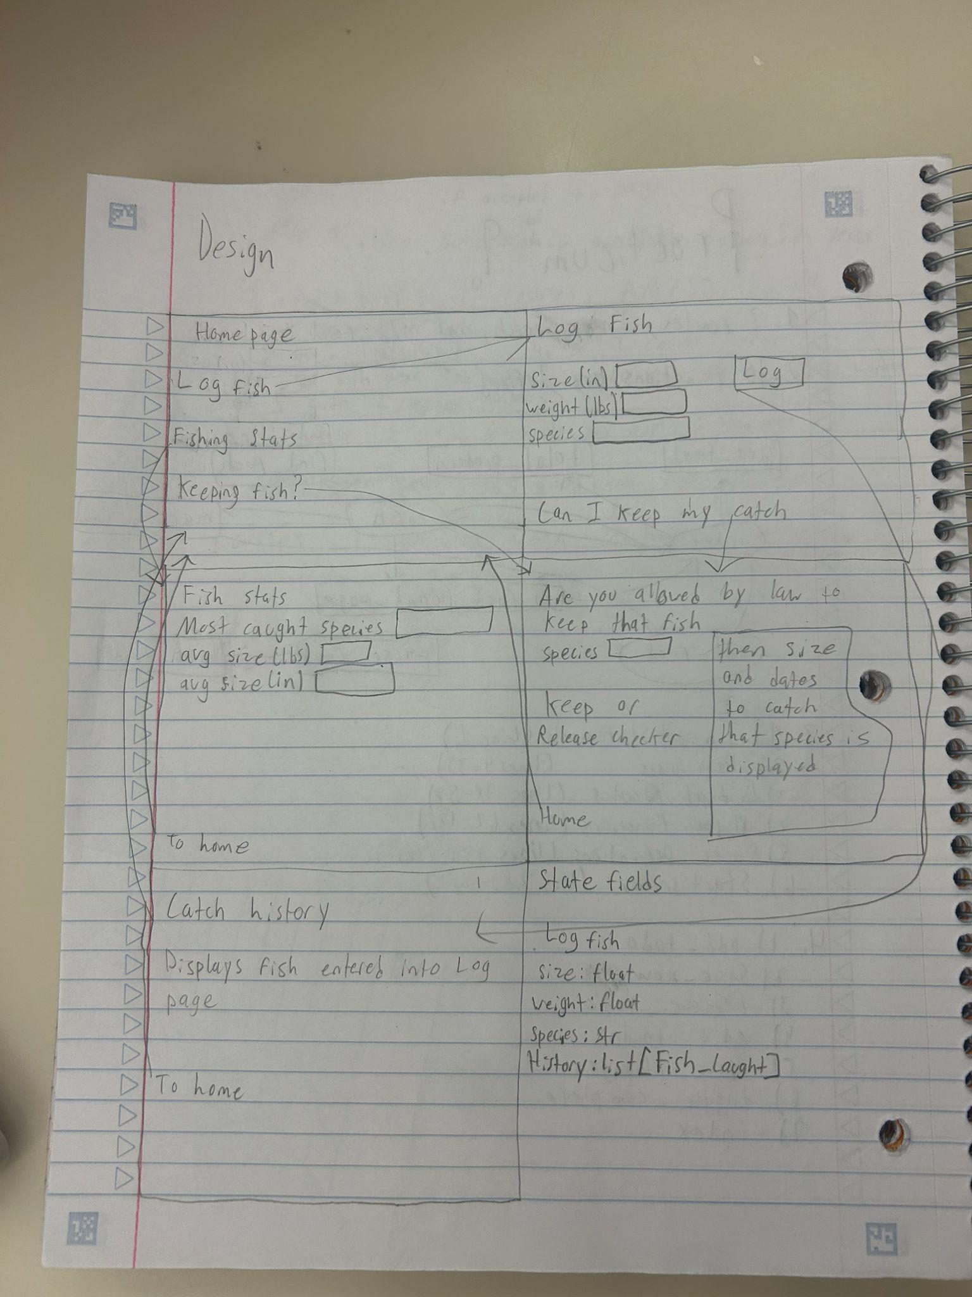2) Implementing Requirements
This table should serve as a draft for how you will implement the requirements into your final project. You may change your ideas later on, but your final site must fulfill all the requirements.

Requirement | Implementation
Purpose/Functionality  A 1-2 sentence description of the purpose or functionality of your site | The site lets the user enter a fish that they have caught, then it puts that into a history, and it averages the weight and length. There is another page that lets you enter a fish and then checks if it’s a legal fish to keep(based on size and time of year).
State Dataclass Attributes  Minimum of 4 attributes, one of which must be a list/dict of instances of your second dataclass.  Briefly describe each attribute, its type, and how it will be meaningfully modified throughout the site. | The state is Log_Fish, and its attributes are size: float, weight: float, species: str, and history: list[Fish_Caught]. The size, weight, and species will be logged and used to check if a fish is legal and averaged for stats. The history will be used so you can look back and see the stats for the fish you have caught. Size is a float and is for the length in inches of the fish; the weight is in pounds and is a float for how much the fish weighs. The species is a string and is for logging the kinds of fish you catch. The history is just a list of all the fish caught.
Second Dataclass  Your second dataclass, including its attributes, their types, and how they will be meaningfully modified (if they are modified) | A dataclass that will be used is fish_caught, one that will take in the fish length(float), weight(float), and species(str). This is a different dataclass that will be used for the averages. Rather than the first one for the history. This one will be used to calculate the average and showcase all the fish caught’s average size and such.
Routes (minimum 7)  The names of your route functions | Homepage, Log_Fish, Fish_stats, Keep or Release Checker, Catch_History, Log, and Average_Catch.
Pages (minimum 5)  A brief description of the pages in your site | The first page is a homepage that can then take you to all the other pages. The Log fish page is where you can enter the data for a fish. Average page is where a your fish catch averages are shown. Keep or Release checker checks if you can keep a fish that’s info is entered into that page. The final page shows all the fish that have been entered in a list.
User Input (minimum 3)  Description of user input components (TextBox, TextArea, CheckBox, or SelectBox) and their purposes  For more information on these input types, see Drafter Documentation. | Many TextBoxes will be used because a user has to input lots of data, such as fish species, weight, and length, which are 3. Also, for the keep or release checker, a species will be entered, and the rules and regulations will appear after it’s entered for that species.
If Statements (minimum 3)  Brief description of what will be evaluated in your if statements and how they will meaningfully change the logic of the site | An if statement for the keep or release checker will have multiple if statements; two examples are if it’s a sturgeon, then a message will be returned saying illegal return to water now. Another could be if it’s a trout and it’s caught in the winter, it’s illegal and should be returned. Another if statement is if the length of the fish is negative, then it should be ignored because it’s not possible.
Loop (minimum 1)  This loop must iterate over the list/dict of dataclass instances in your State attribute.  Description of this loop and why it is meaningful to the site | A loop will be used to average all the fish sizes and weights. It’s meaningful because one of the pages is the averages of the fish entered.

LLM Conversation
If you used an LLM in any part of this work, copy and paste every part of that conversation below. Otherwise, you may be given a zero for the assignment. Obviously, these words will not all be yours, and this is the exception to the requirement at the top of this assignment that all responses be in your own words. If you did not use an LLM to assist you in this assignment, simply say so below.
I didn’t use any LLM’s for this assignment.

Final Submission
When you are finished, download this file as a Word Document (docx) and upload the file to the appropriate assignment on Canvas.

